**Remotely monitor and control devices with Azure IoT Hub**

To keep things simple in this lab,

The device will send telemetry (temperature and humidity values) to the IoT Hub every few seconds. Although this frequency is unrealistic for a cheese cave, it is great for a lab environment when we need to see changes frequently, not every 15 minutes.

* The air processing system is a fan that can be in one of three states: On, Off, or Failed.
  + The fan is initialized to the Off state.
  + **Electrical power** to the fan is **controlled (On/Off)** using a **direct method** on the **IoT device**.
  + **Device Twin desired property values** are used to **set** the **desired state** of the fan. The desired property values will override any default settings for the fan/device.
  + **Temperature** can be **controlled** by **turning** the **fan On/Off** (turning the fan On will lower the temperature)

Coding in this lab is broken down into **three parts**:

1. **sending and receiving telemetry**,
2. **invoking and running a direct method,**
3. **setting and reading device twin properties.**

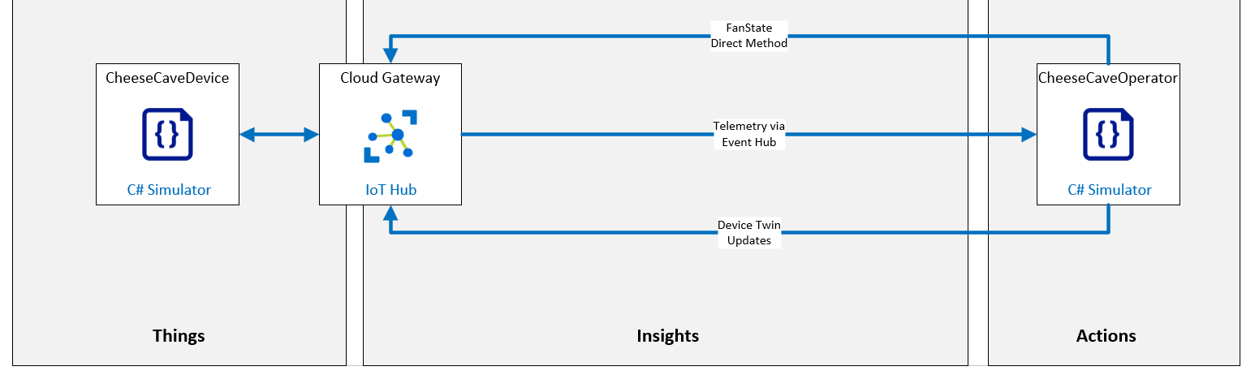

|  |  |
| --- | --- |
| Resource Group | rg-az220 |
| IoT Hub | iot-az220-testing-0001 |
| IoT Device | sensor-th-testing-0001 |

### **Exercise 2: Write Code to Send and Receive Telemetry**